**BeerList & Beer Page Design**

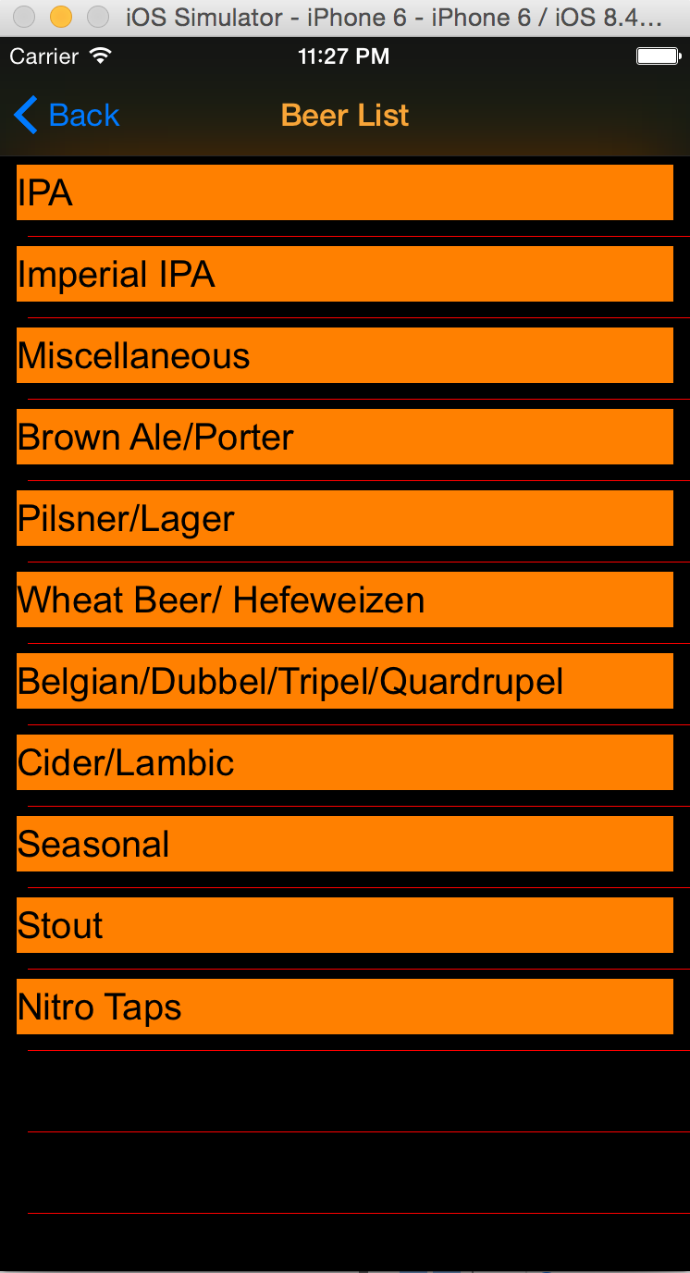

**Elements:**

Title: Beer List, orange

Navigation Buttom: “Back”, blue; back to last page(menu)

View Backgroud: black

Cell Background: black

Cell content:

Label, orange background, black text

Cells Separator: red single line

**Elements:**

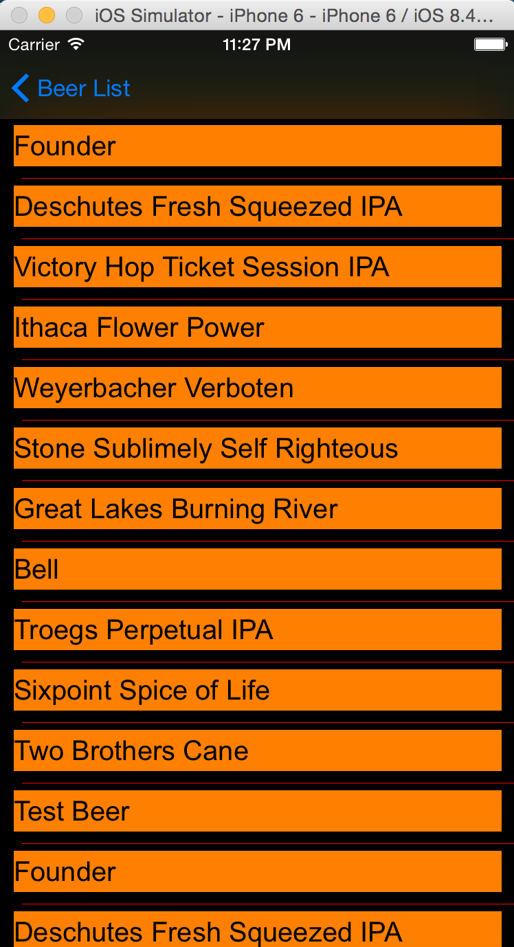

“Back” Buttom: “Beer List”, blue; back to Beer Type List table

View Backgroud: black

Cell Background: black

Cell content:

Label, orange background, black text

Cells Separator: red single line